First Responder Wellness

COPLINE 24-hour Confidential Support Line 800-267-5463
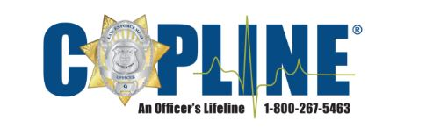

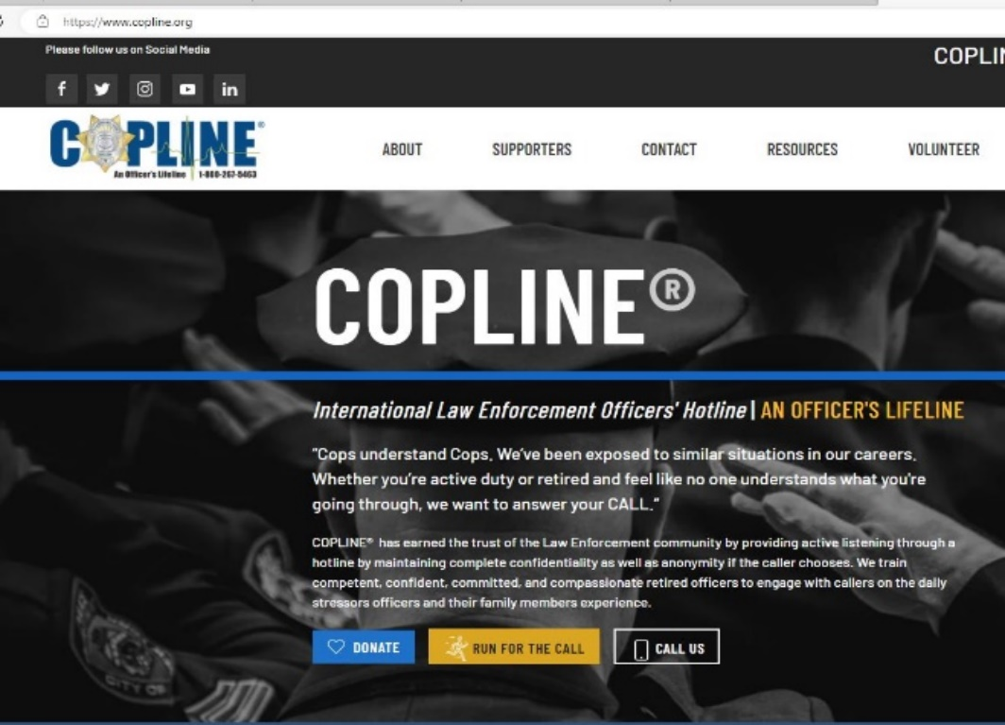

Safe Call Now
24-Hour First Responder Crisis Hotline: 206-459-3020

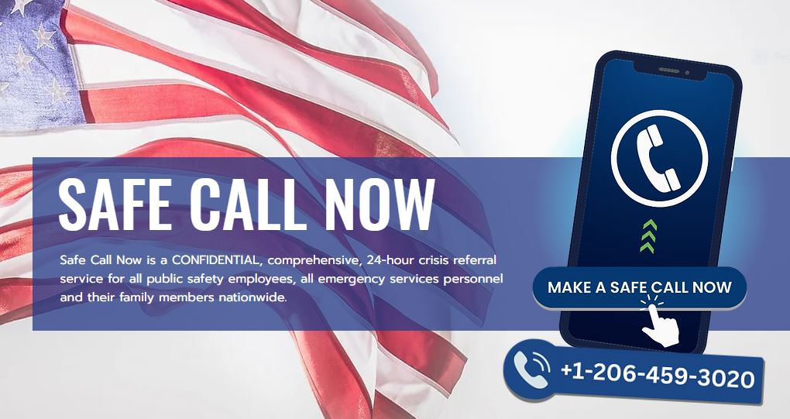

Emotional Survival for LE
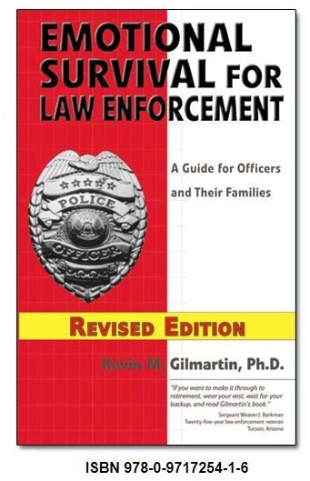

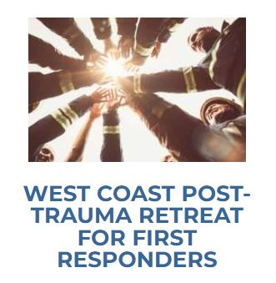
First Responder Support Network (FRSN)
Support for First Responders. By First Responders
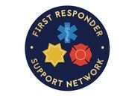
*see brochure
FAQ
Resources

First Responder/First Responder Family Meetings
Crisis Resources
Find a Clinician (People who have experience working with First Responders)
Retreats
- West Coast Post-Trauma Retreat (WCPR) is a residential program for first responders whose lives have been affected by their work experience
- Significant Others and Spouses Retreat (SOS) is a residential program for emergency responder partners and spouses who have been affected by their loved one’s critical incidents (resulting in secondary or vicarious trauma), but may also be experiencing symptoms
The Overwatch Collective (T.O.C.)
Podcast and Non-Profit Supporting Mental Health among First Responders, Military, and Families
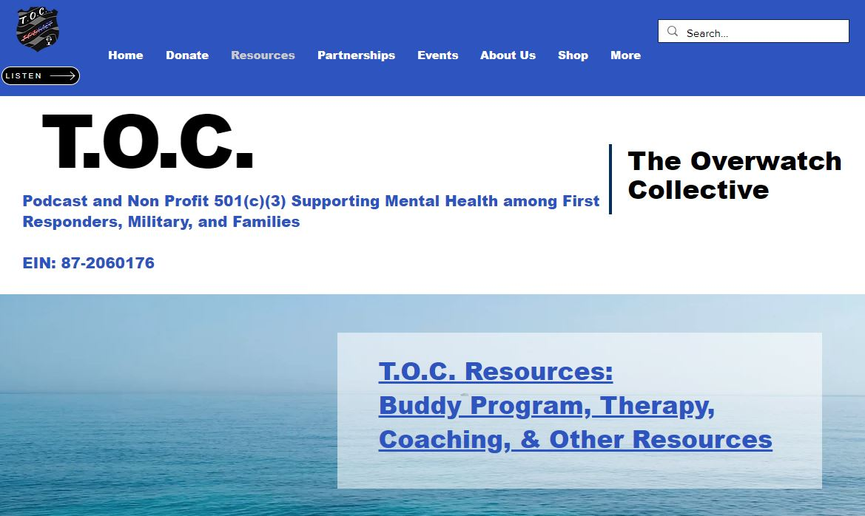
TOC Resources & Family

Lighthouse Health & Wellness
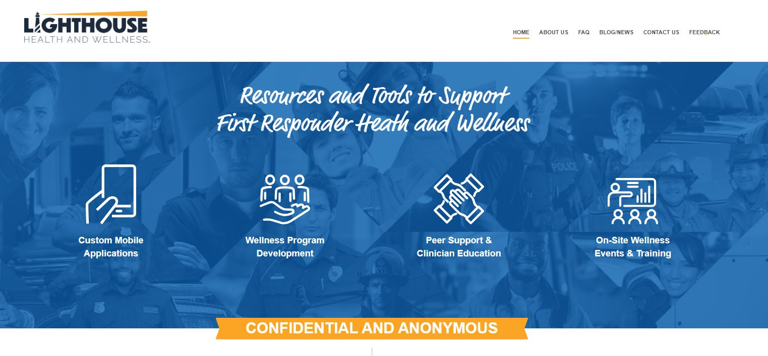
Free Apps and Resources for First Responders
FAQ

First Responders Resiliency, Inc.
24/7 Warm Line: Non-Emergent for those seeking mental and emotional support
855-845-7415
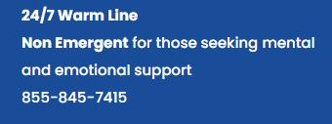
Family Services
Resiliency Program
Upcoming Trainings
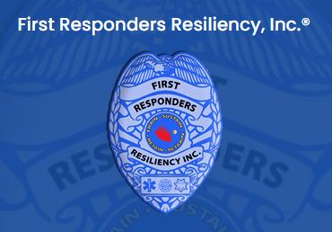

Cops Alive
Information, strategies and tools to help cops plan happy, healthy and successful careers, relationships, and lives



The Pain Behind the Badge
Suicide prevention and resources


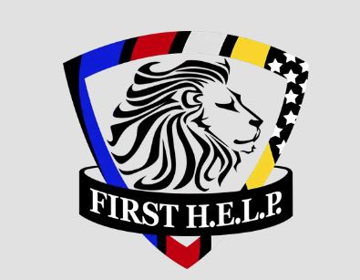
FIRST H.E.L.P. works to reduce mental health stigma for first responders through education and awareness and assists first responders in their search for healing
Blue Help
Suicide prevention services for struggling LEO


Courageous Heart: The Human Behind the Badge – Resilience, Compassion and Leadership Training for LE and Public Safety
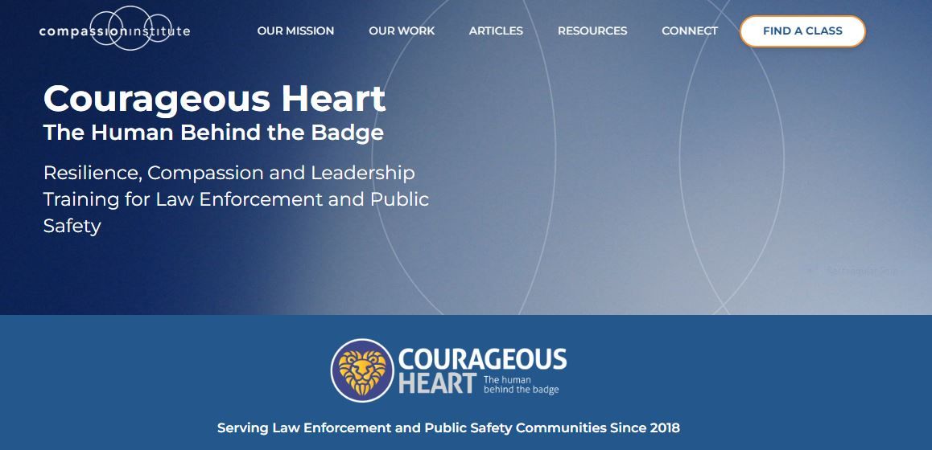

Hold the Line Fly Fishing is a non-profit whose mission is to lessen the emotional and physical effects of PTS/PTSD in First Responders through fly fishing and brotherhood



809 Fight for Awareness is a non-profit whose mission is to increase compassion and aid for those living with mental health challenges, and to promote optimal mental health in first responders through peer support and advocacy


First Responder Therapy Dogs leads the way in addressing the mental health needs of first responders by providing emotional support using therapy dogs. Provide this free service to as many free responders as possible

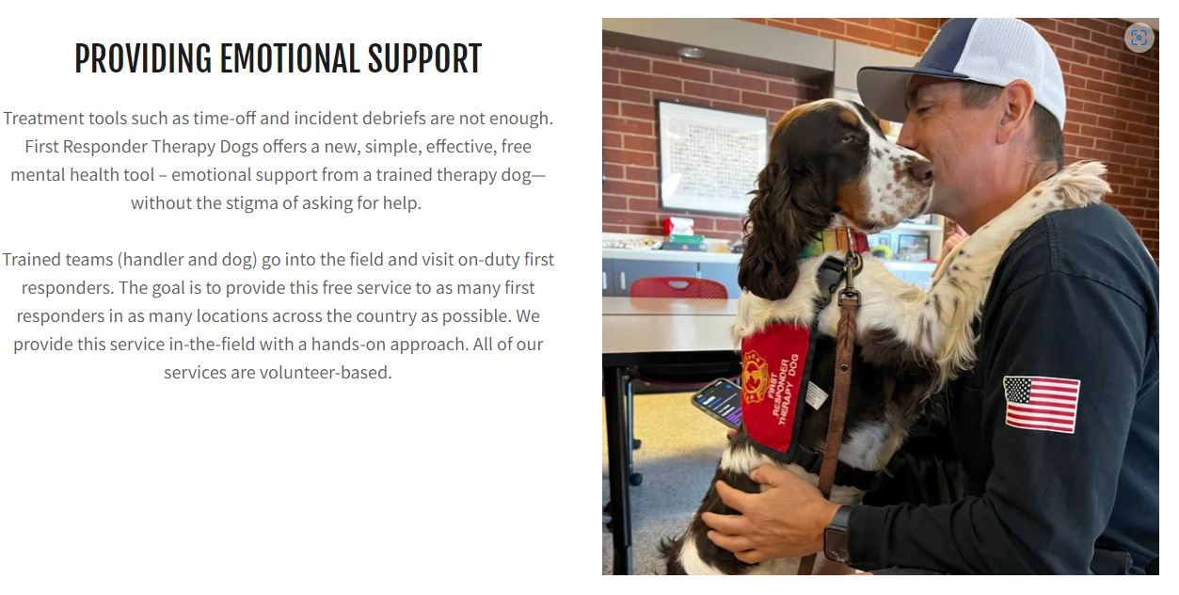

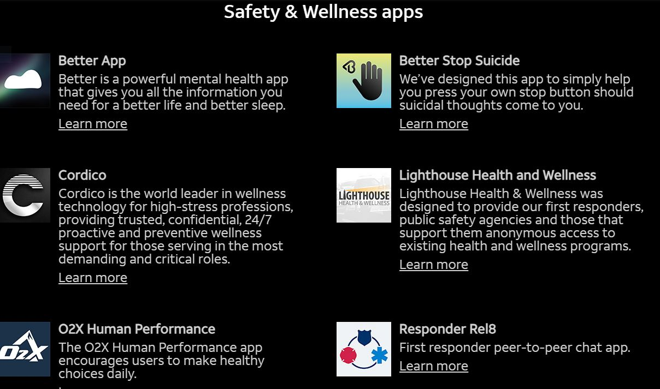

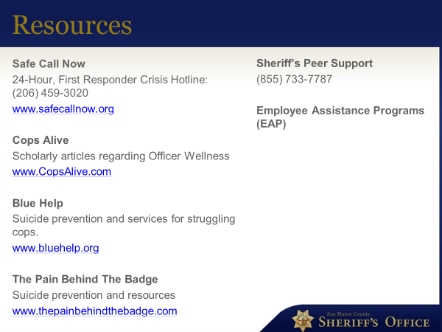

San Mateo County Sheriff’s Peer Support: 855-733-7787

Volunteers of America – ReST (Resilience, Strength, Time) for First Responders
VOA|ReST 4 First Responders offers free, peer-to-peer small group support sessions designed to help First Responders process feelings of moral discomfort and distress while reclaiming strength and commitment to their profession.
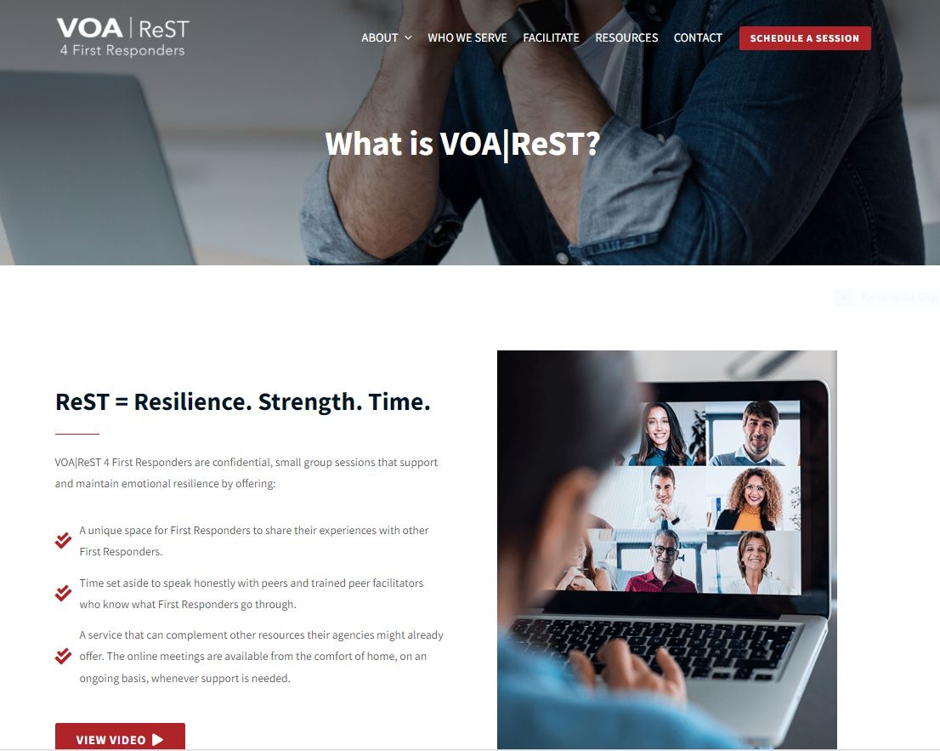

Employee Assistance Programs (EAP) – contact HR

